***Additional references***

<https://www.youtube.com/watch?v=uYGQcmZUTaw>

<https://www.youtube.com/watch?v=QXylwLWrk14&feature=youtu.be>

There are three types of service models in cloud − IaaS, PaaS, and SaaS

There are three types of deployment models in cloud - Private, Public and Hybrid Cloud

Lets understand each type in detail.

1) Software as a Service (SaaS)

2) Platform as a Service (PaaS)

3) Infrastructure as a Service (IaaS)

<https://youtu.be/36zducUX16w>

<https://youtu.be/X_ZZO-oeNeg>

History of AWS: <https://www.youtube.com/watch?v=f8rOXI4VZQA>

Additionally, you can go through the below learning videos for further knowledge on the topics.

**AWS Account Creation:**

* <https://www.youtube.com/watch?v=_siSwgpVQNc>

**AWS Management Console Overview:**

* <https://www.youtube.com/watch?v=A43m4TDFCUM>

**Understanding the Free Tier Usage and Restrictions:**

* <https://www.youtube.com/watch?v=rkKvzCskpLE>
* <https://www.youtube.com/watch?v=8p1bTTV6ATE>

Free Tier Usage Tracking/How do I Check if I am Exceeding the Free Tier Limit?

* <https://www.youtube.com/watch?v=_CWKK0sypkE>
* <https://www.youtube.com/watch?v=h1lICrHEmiA>

**COMPUTE**  
1. EC2

Amazon Elastic Compute Cloud (Amazon EC2) is a web service that provides resizable compute capacity in the cloud.

<https://youtu.be/TsRBftzZsQo>

The following video will give an understanding of the below topics.

* What is EC2?
* How does it work?
* What are its components?

<https://youtu.be/dO1X7QG_4xw>

Selecting proper AMI is very important to properly use an EC2 instance. The following video will show the basics of AMIs. It covers the following:

* What is AMI
* Components of AMI
* Conceptually Understanding AMIs
* Selecting an AMI

<https://youtu.be/B7M31vywgs4>

In this section we shall learn how to launch an EC2 Ubuntu instance through the AWS Management Console and how to connect and access the instance through Putty and WinSCP.

<https://youtu.be/Ce876F9soxA>

In this section we shall learn how to launch an EC2 Windows instance through the AWS Management Console and how to connect and access the instance using Remote Desktop Protocol (RDP).

<https://youtu.be/O6ZSU0MBT2w>

**Alternate Tutorial Video:**

* <https://www.youtube.com/watch?v=Edm0agGXxu0>

2. AWS Lambda

AWS Lambda is a compute service that runs your code in response to events and automatically manages the compute resources, making it easy to build applications that respond quickly to new information. The following video will give a brief overview of AWS Lambda.

<https://youtu.be/eOBq__h4OJ4>

The following video will give an understanding of the below topics.

* What is AWS Lambda?
* How does it work?
* Components of AWS Lambda
* Lambda Functions
* Event Sources

<https://youtu.be/DcF7xgYEvQw>

**Alternate Tutorial Video :**

* <https://www.youtube.com/watch?v=iUIWG0h2D84>

The following video will give an understanding of the below topics.

* What is AWS Lambda?
* How does it work?
* Components of AWS Lambda
* Lambda Functions
* Event Sources

<https://youtu.be/DcF7xgYEvQw>

**Alternate Tutorial Video :**

* <https://www.youtube.com/watch?v=iUIWG0h2D84>

The following video will show how AWS Lambda works and how to create Lambda functions in the AWS Management Console.

<https://youtu.be/seaBeltaKhw>

**STORAGE**

In this section we shall discuss about the Amazon Simple Storage Service (S3).

<https://youtu.be/77lMCiiMilo>

The following video will give an understanding of the below topics.

* What is S3?
* Components and Structure of S3
* Pricing/Cost Overview

<https://youtu.be/f9hXcxHnQuE>

Below tutorial video will show a detailed demonstration on how S3 works and how to perform the following operations in the AWS Management Console.

* Create S3 bucket
* Store objects in the S3 bucket
* Play around with accesses and permissions
* Access your files or images anywhere from the world
* Work on versioning
* Static website hosting in S3

<https://youtu.be/1nw25qWxonc>

**Alternate Tutorial Video (Brief Hands-on):**

* <https://www.youtube.com/watch?v=4v-D1Ng-Ebo>

**DATABASE**

In this section we shall discuss about two important AWS database services.

1. Amazon Relational Database Service (RDS)

The following video will give a brief overview of the Amazon Relational Database Service (RDS).

<https://youtu.be/eMzCI7S1P9M>

The following video will give you a detailed understanding of Amazon RDS and its various features.

<https://youtu.be/SyOOA3pCVRU>

The below tutorial video will show a step-by-step demonstration of how to set up a RDS MySQL server (that is accessible over the internet) using the AWS Management Console. It will also show how to connect to the database using MySQL Workbench and how to execute some basic SQL queries.

<https://youtu.be/Ng_zi11N4_c>

**Additional Tutorial Video : (Setting-up a RDS MySQL Server and accessing it from an EC2 instance)**

* <https://www.youtube.com/watch?v=lyBs2rhpVnE>

1. Amazon DynamoDB

The following video will give a brief overview of the Amazon DynamoDB.

<https://youtu.be/sI-zciHAh-4>

The following video will give a detailed understanding of Amazon DynamoDB, its features, object model and how to use it.

<https://youtu.be/MZwFBUCJRkE>

**Alternate Tutorial Video :**

* <https://www.youtube.com/watch?v=G4qev4vV8k4>

<https://youtu.be/G4qev4vV8k4>

The following video will discuss about the Amazon DynamoDB features and it will also show a detailed demo on how to use and scale Amazon DynamoDB using the AWS Management Console.

<https://youtu.be/2mVR_Qgx_RU>

**Alternate Tutorial Video:**

* <https://www.youtube.com/watch?v=BdQLwSWn0Z8>

**Networking tools**

Amazon Web Services (AWS) provides the Networking tools and resources that enable you to securely connect to the cloud and then isolate, control, and distribute your applications across EC2 compute resources and all other relevant services in AWS. Networking Solutions available from AWS Partner Network (APN) partners can help you establish your secure, scalable, cost-effective cloud presence more rapidly. Whether you are planning to migrate to AWS or are looking to expand your established network capabilities on the cloud, there are readily available tools and resources at your disposal to accelerate the realization of your goals.

**Amazon Route 53**

Scalable Domain Name System

<https://youtu.be/BtiS0QyiTK8>

**VPC**

[**https://youtu.be/fpxDGU2KdkA**](https://youtu.be/fpxDGU2KdkA)

**V V IMP.**

[**https://youtu.be/fpxDGU2KdkA**](https://youtu.be/fpxDGU2KdkA)

[**https://youtu.be/gUesnoDzNr4**](https://youtu.be/gUesnoDzNr4)

**Hands on:** [**https://youtu.be/gUesnoDzNr4**](https://youtu.be/gUesnoDzNr4)

**Additional reference :**

**Link 1:** [Digital Cloud Training](https://www.youtube.com/channel/UCZGGwqjk5jfO4vN1SOCJ2ew) **creating custom vpc**

<https://www.youtube.com/watch?v=Wa0JTKhbsOY>

***Paid Hands on link:***

[**https://amazon.qwiklabs.com/focuses/11046?catalog_rank=%7B%22rank%22%3A20%2C%22num_filters%22%3A0%2C%22has_search%22%3Afalse%7D&parent=catalog**](https://amazon.qwiklabs.com/focuses/11046?catalog_rank=%7B%22rank%22%3A20%2C%22num_filters%22%3A0%2C%22has_search%22%3Afalse%7D&parent=catalog)

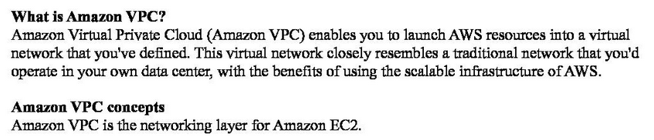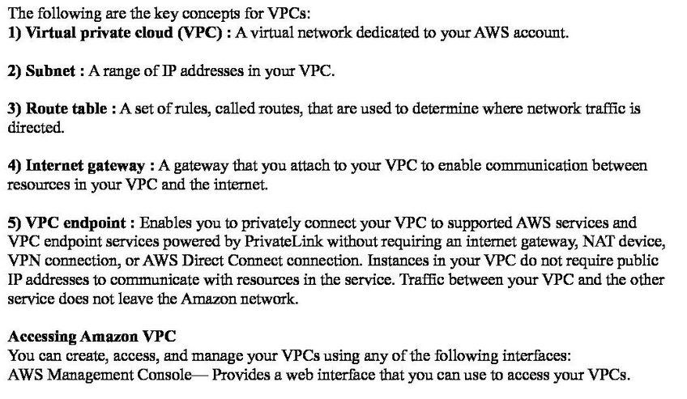

**AWS Identity and Access Management (IAM)**

Controls Users Access To Aws Services, Allows To Create, Manage Users And Groups, And Deny Or Grant Access.

<https://youtu.be/UqKWHZ36yEM>

<https://youtu.be/UqKWHZ36yEM>